The National Forest Gardening Scheme CIC

"Climate Resilience: Think and Act like a Forest Garden"

Venues in Manchester City Centre, Hulme & Rusholme

Saturday 28th September 2019

Part 1: Climate Resilience: Think and Act like a Forest Garden

C/o Friends Of the Earth @ Green Fish Resource Centre 46-50 Oldham St, M4 1LE

10.15-10.30 |  | Arrival and registration
10.30-10.45 |  | Welcome, framing the conversation | Paul Pivcevic
10.45-12.30 |  | Round table discussion: The role of forest gardens in bioregions, climate resilience and all sorts of spaces – garden like a Forest!
12.30-13.00 |  | CLOSE and move to Hulme Community Garden Centre
Part 2: AGM for the national forest gardening scheme (NFGS) and launch of the ‘Forest Garden in a Box’ concept

@ Hulme Community Garden Centre. 28 Old Birley St, M15 5RG

13.00-14.00 |  | Shared lunch. We request you bring your own food to share  We will provide teas, coffee and milk | Jane Morris /Richard Luff
14.00-15.00 |  | AGM. Key elements:  - NFGS as a CIC  - Directors re-nomination  - CIC Membership confirmation  - NFGS report on activities and finances (since AGM Sep 2018) | Hannah Gardiner
15.00-16.00 |  | ‘Forest Garden in a Box’ introducing the concept, launch of protype(s) and workshop to refine the approach, product and plans for promotions | Hulme CGC
16.00-16.30 |  | CLOSE and clear up and move to Birchfields Park
Part 3: Tour of Birchfields Park Forest Garden, NW corner of the Park,

near Birch Polygon and Dickenson Road with approach via Norman Road, M14 5JU

16.30-17.30 | Jane Morris and fellow forest gardeners will lead a walk and tell the story of this (over 12 years old) publicly owned Forest Garden and explore its potential (programme to be adjusted depending on the weather) |  | Jane Morris

We are covering some (maybe all) costs via ticket sales/donations. If we face a shortfall because of room hire costs we will ask for further donations on the day. Thanks for your support.
Maps of key locations in Manchester
Sat Morning Green Fish Resource Centre, 46 - 50 Oldham St, Manchester M4 1LE
Sat lunch/afternoon Hulme Community Garden Centre. 28 Old Birley St, Manchester M15 5RG
Sat Late afternoon Birchfields Park Forest Garden [within Birchfields Park], between Birch Polygon and Dickenson Rd/A610

Please self-organise to move between each venue in the timeframe allocated. This means using shared taxis or any cars that are around, or cycling, using buses and walking takes too long – Sorry time is tight!

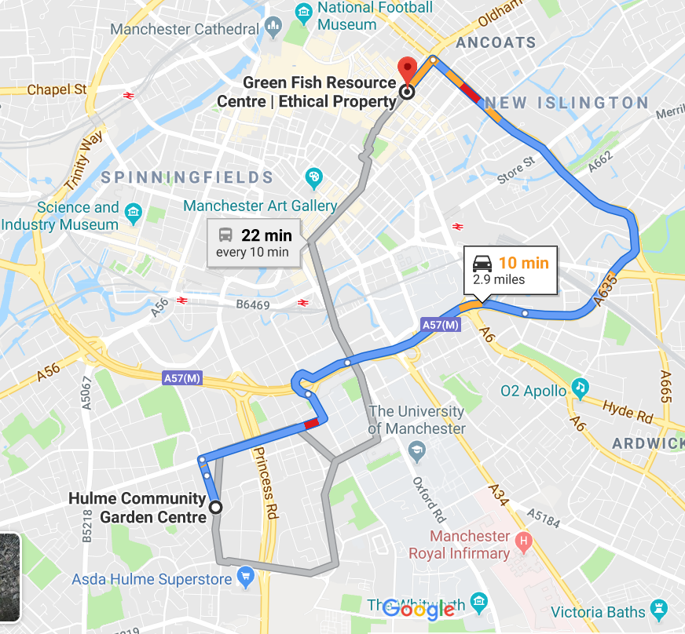

*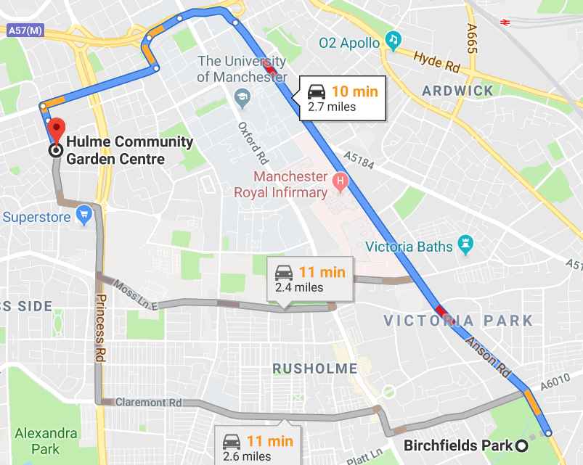
Birchfields forest garden

More Information and Bookings via
http://nationalforestgardening.org/2019/07/24/climate-resilience-think-and-act-like-a-forest-garden/

